Studio: 3 City rd,

Auckland 1011

Ph: 0212605364

Email:biancawaiheke@gmail.com

Web: www.dubontcreative.co.nz

Internal Documentation

Breads by Josef

Prepared for: Concepts By Josefson Ltd aka Breads By Josef

PO Box 20135

Shortland St

Auckland

Ph: 09 378 5642

Contact person: Josef Josefson

Prepared by: Bianca Sanders-Director of Du Bont Creative

Project ref . Domain: [www.breadsbyjosef.co.nz](http://www.breadsbyjosef.co.nz)

Proposal date: 22 February 2016

Project commencement: 22 February 2016

Project Completion: 3rd March 2016

Contents

01 Client Overview

02 Project Description

03 Target Audience

04 Competitors Site Analysis

05 Website research

06 Logo Design

07 Sketches for website

08 Fonts and Colors

09 Website mock up

10 Usability Review

11 Resource links

Client overview

**Breads by Josef**

Breads by Josef is situated in Parnell, Auckland city.

They pride themselves on using traditional backing techniques derived from Germany & France. BBJ bread is a handmade using 100% organic ingredient.

The breads are baked on slate stone tiles, which ensures the loaves are tender and moist with a dense & tasty flavor.

Breads by Josef serve fresh Organic coffee & have a range of fresh juices & smoothies created on site to enjoy there or takeaway.

The owner of BBJ is Josef Josefson, was appointed the first Culinary Ambassador to the city of Timaru. He has trained in many of Europe’s finest hotels & restaurant’s. He is renowned in the culinary community for the prestigious Chevalier de l’Orde du Merite Agricole de la Rebublique francaise

He is one of nz top baker consultants & has authored a cook book, Bred by Josef & has appeared on the Good Morning television program reviewing regional breads.

BBJ currently have a web presence with a view to update in accordance to new technologies & to promote the business more effectively through web communication.

Project Description

Website design for BBJ

Here are the fundamental requirements, outlined below, for our initial meeting with Josef. The website will include the following mandatory aspects.

* A page including all products & pricing
* A page to announce the Bread of the week
* Social media links
* Contact details & opening hours
* A membership form for potential subscribers
* Google map store locater
* History information relating to BBJ products
* Links to video clips of the TV appearances by Josef
* Shopping cart for Josef cookbook
* Lots of photos of the breads

**Logo design for Breads by Josef**

Du Bont Creative will propose a new logo for BBJ, which will enhance the brand to a high-end market Auckland market.

**Responsive design**

The site is to be designed so that it works effectively displaying on all browsers & devices including Android phones, Iphones, tablets & desktop monitors for all computers.

A test review will be carried out to ensure it follows industry standard design & usability principles.

**Target Audience**

* The majority of customers live or work in Parnell
* Some are happy to travel from surrounding suburbs to buy quality bread
* Health conscious people who are not concerned about cost
* Busy professionals
* Traditional bread lovers
* Mostly adults between 23-60

**BBJ are looking to attract**

* A younger demographic customers aged 16-25
* Corporate business that require catering
* People who are on the internet & social media

Project Constraints

The following constrains need to be observed

* The logo design must be a development of the existing brand
* All color ways to be browser friendly
* All fonts must be common web fonts or embedded web kits

Competitors Site Analysis

1: **Scratch Bakers**

Pros:

* Clear effective design
* Professional photography used

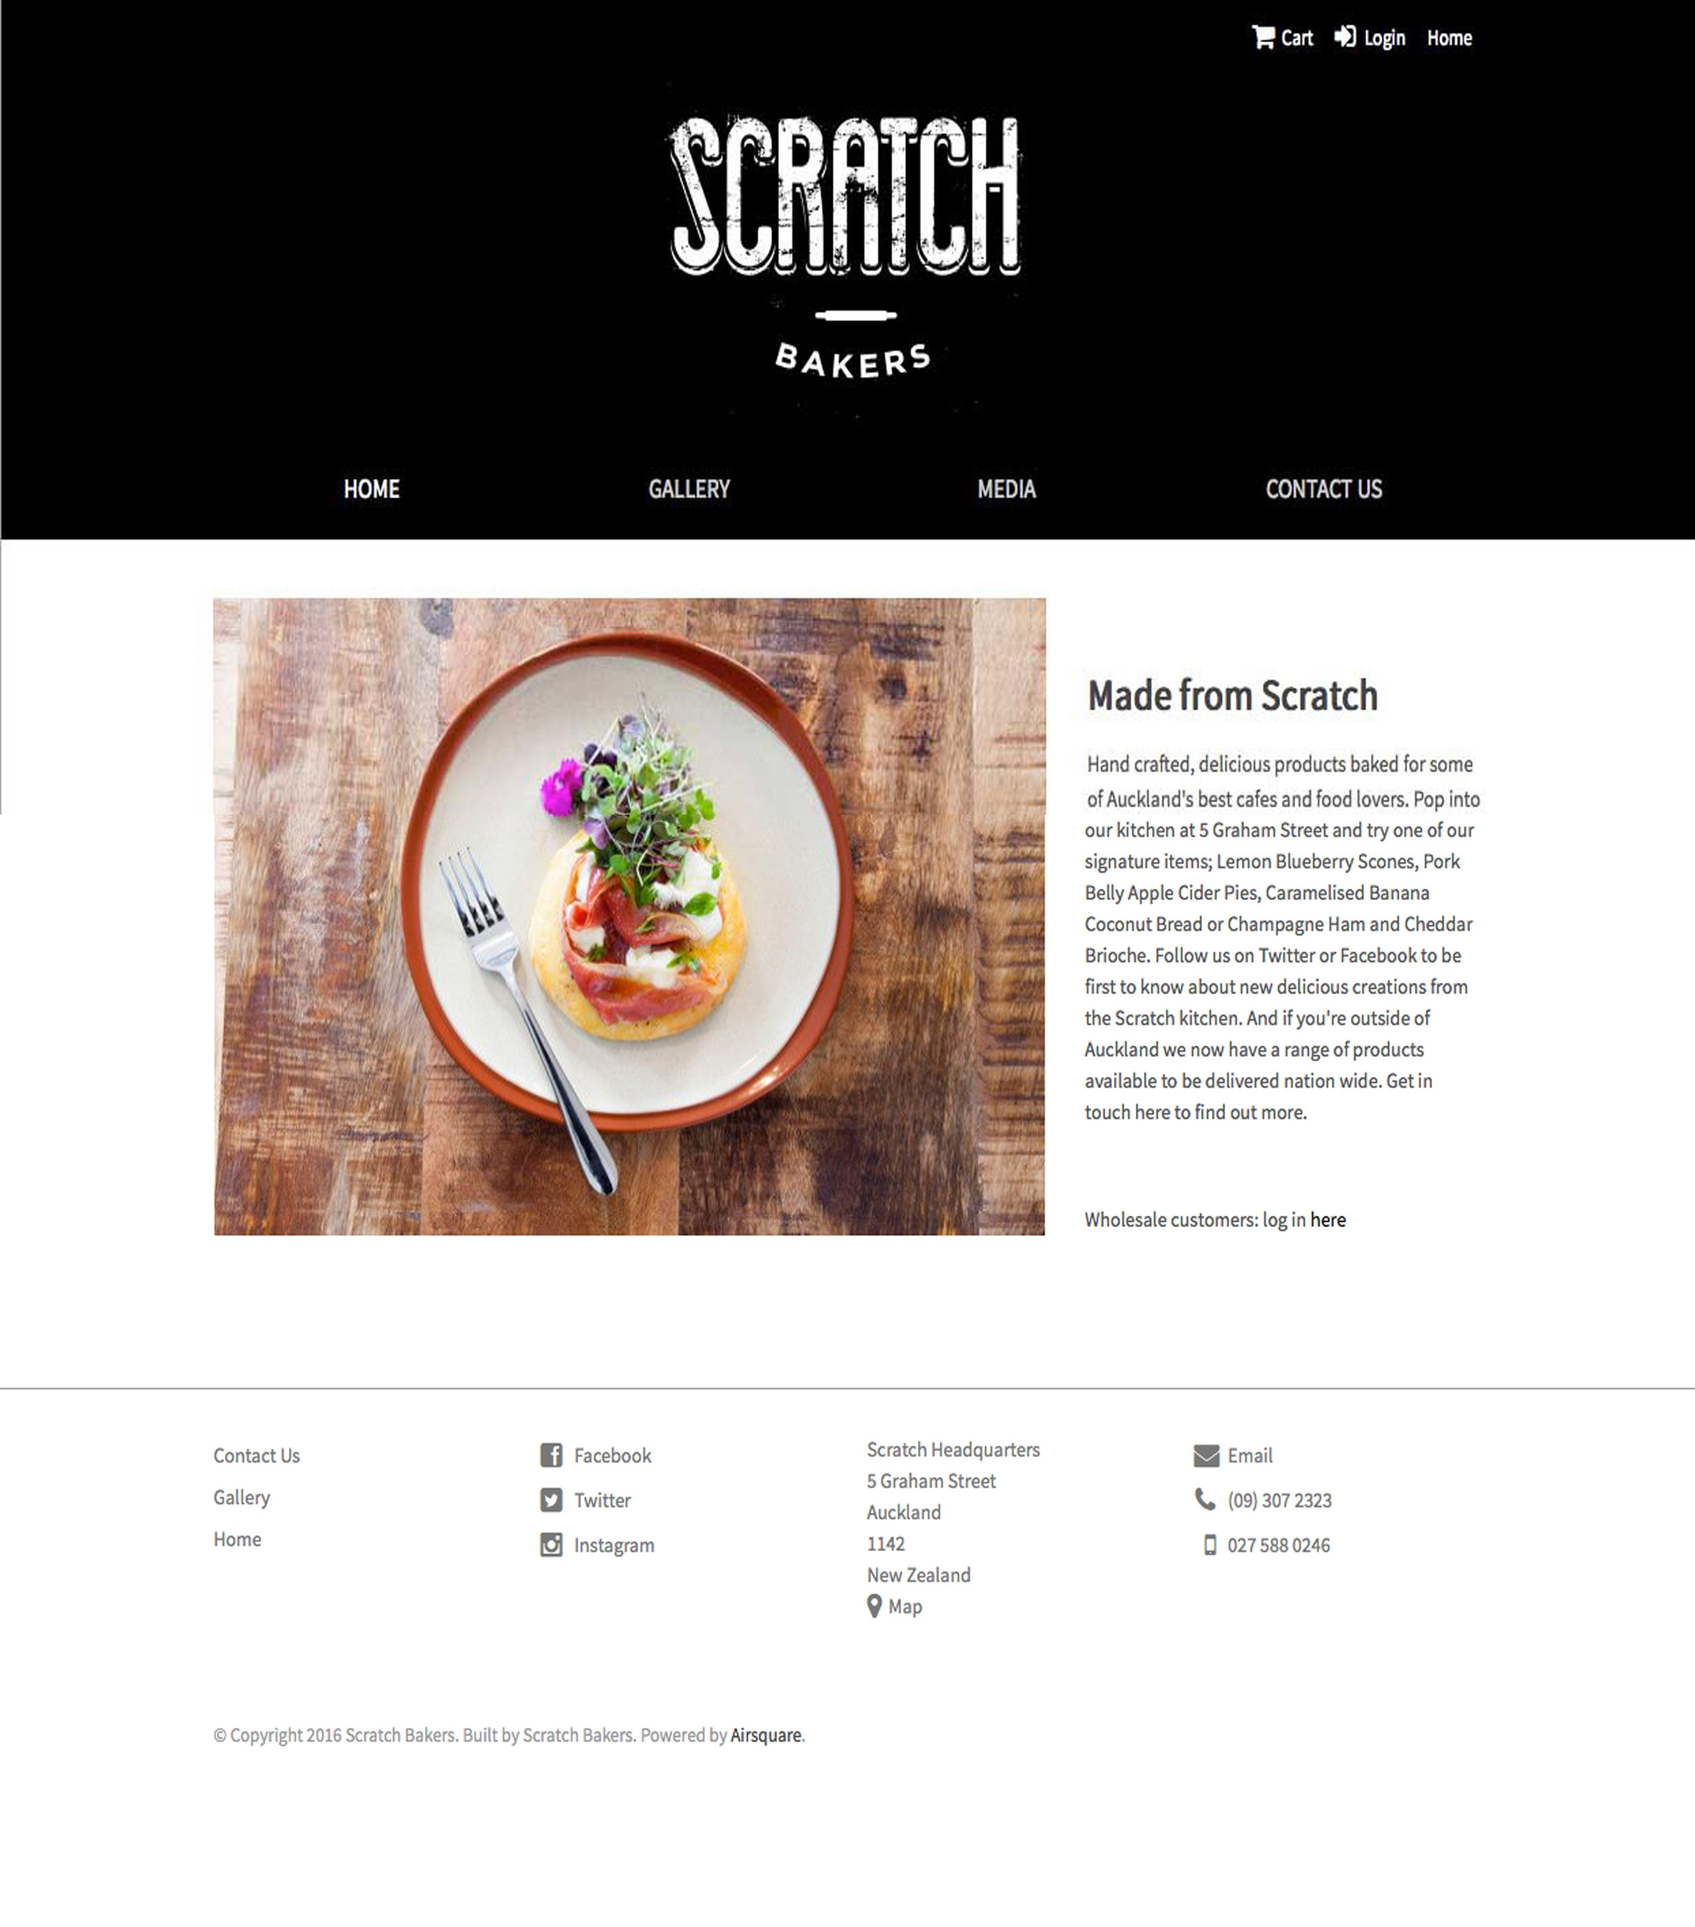

Cons:

* No online ordering
* No product list

2 : **Classic Bake House**

Pros:

* Images representative of the target market

Cons:

* Dated color-way
* Dated logo

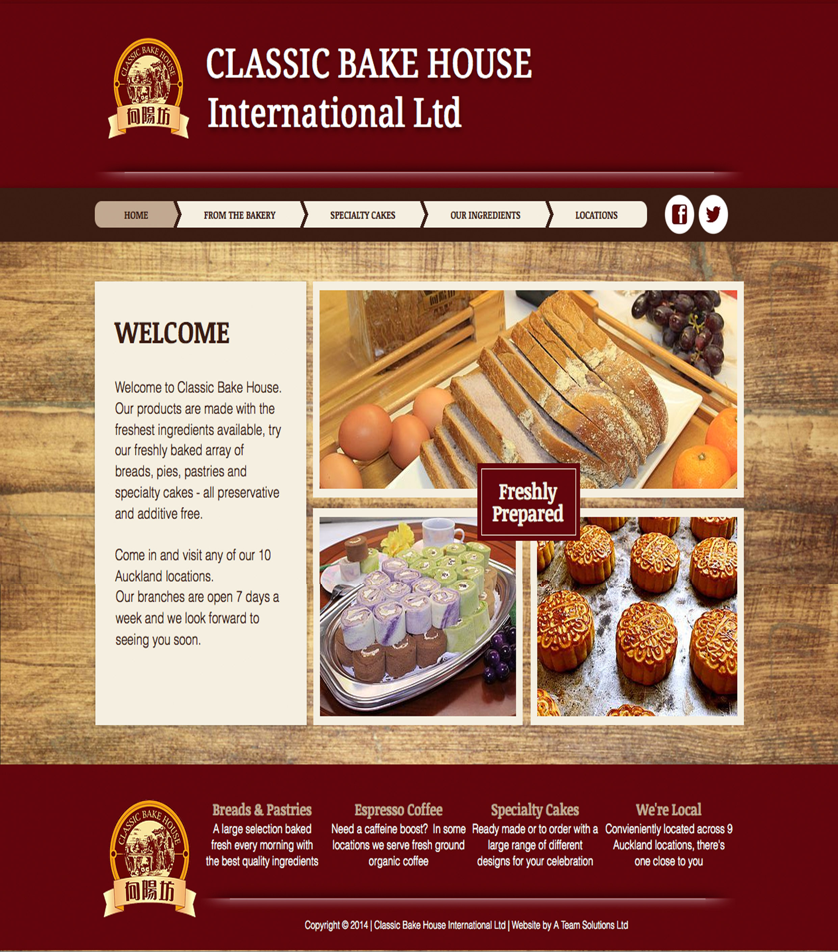

Competitors Site Analysis cont

3: **Pandora**

Pros:

* Images representative of the target market
* Easy to navigate

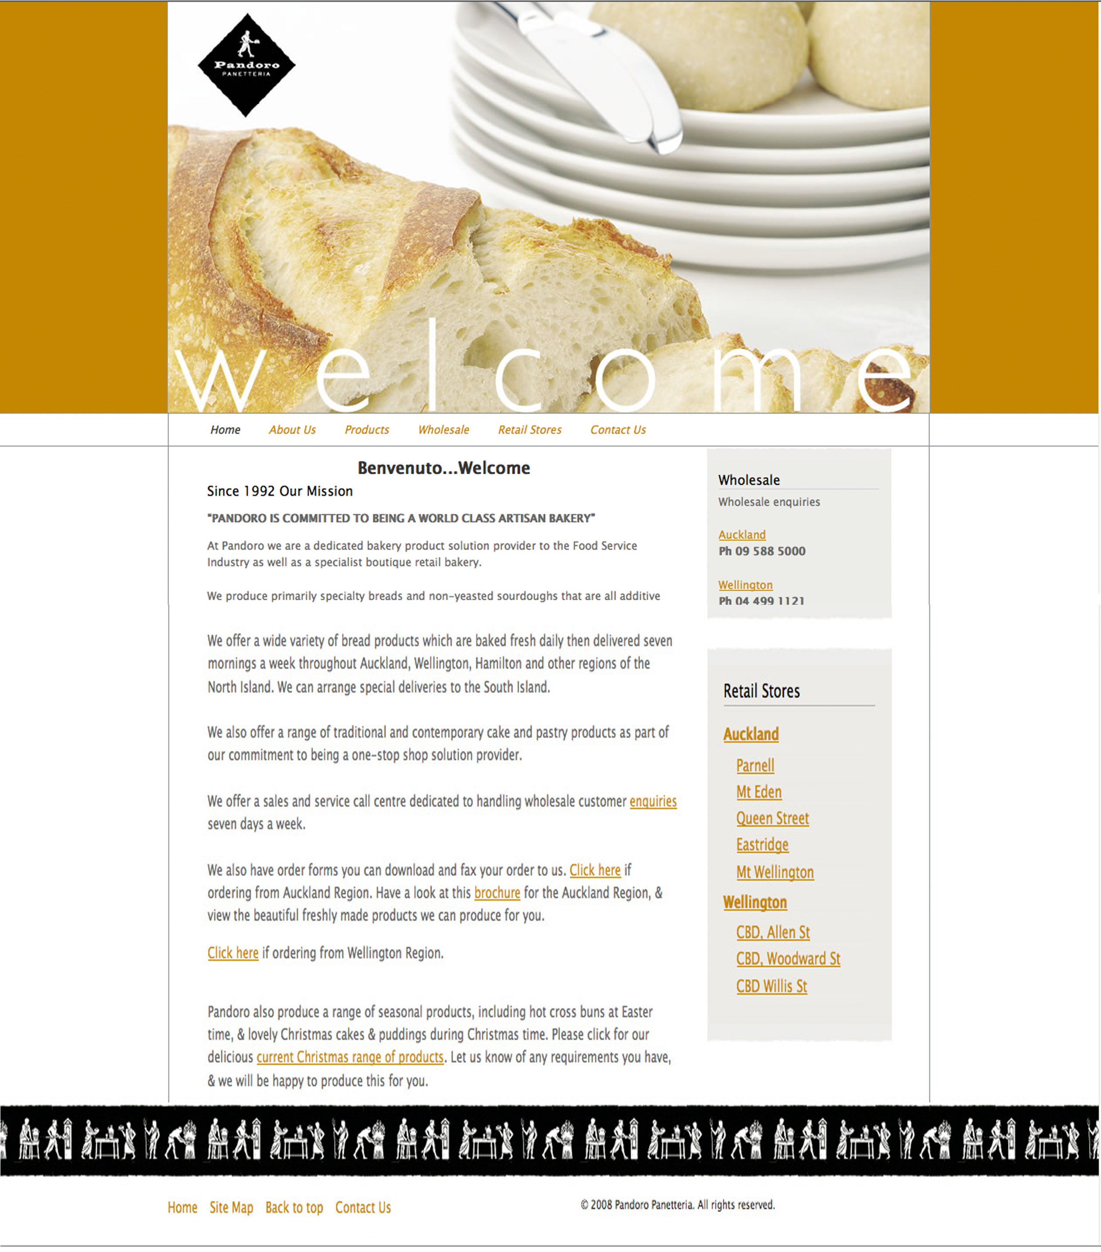

Cons:

* Dated color-way
* Hyperlinks in text

4 : **Pukeko Bakery**

Pros:

* Well laid out
* Easy to navigate

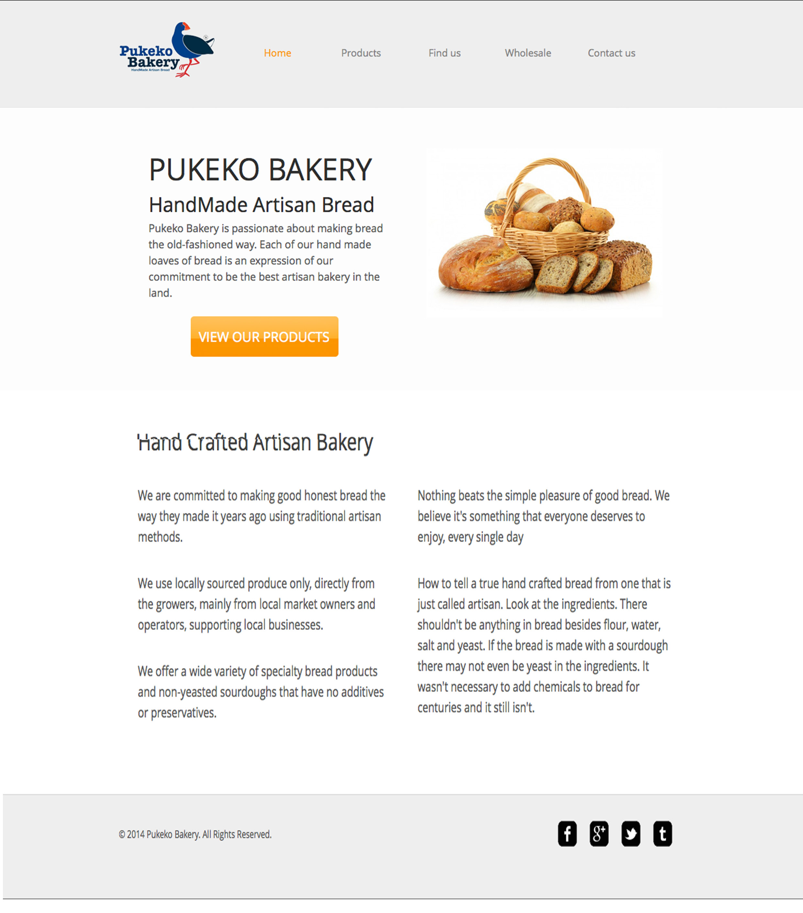

Cons:

* Lacks color
* Needs more imagery

http://www.scratchbakers.co.nz/

<http://www.classicbakehouse.net/>

<http://www.pandoro.co.nz/>

http://www.pukekobakery.com/index.html

Website Research

Here are some examples of well-designed websites

<http://www.simmonsbakers.com/>

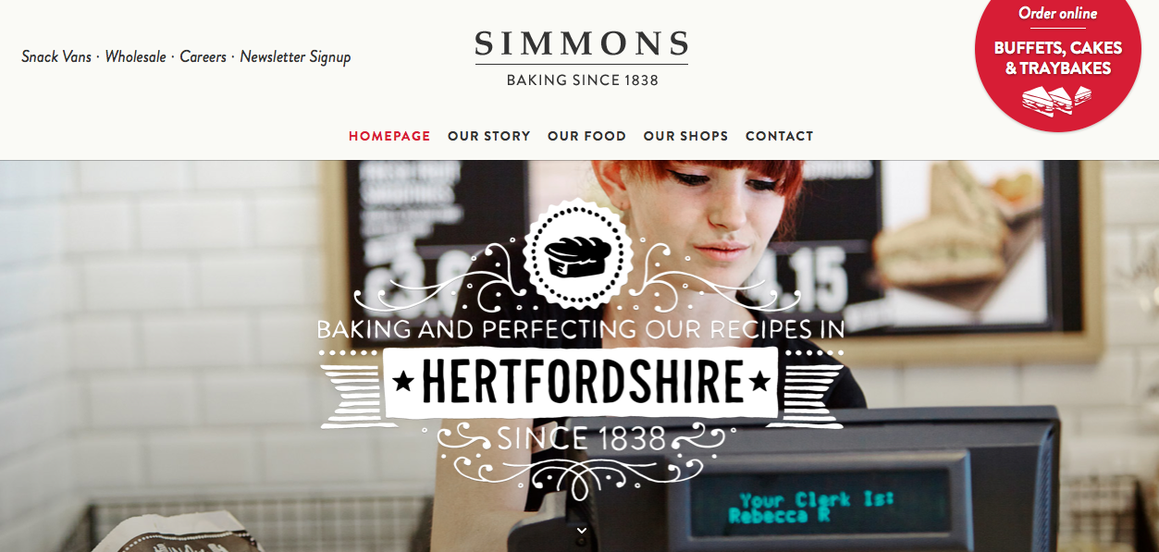 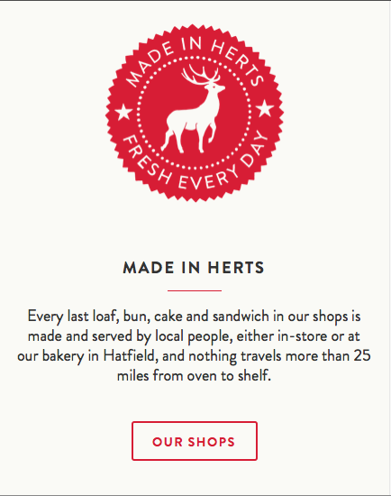

<http://www.pumpstreetbakery.com/>

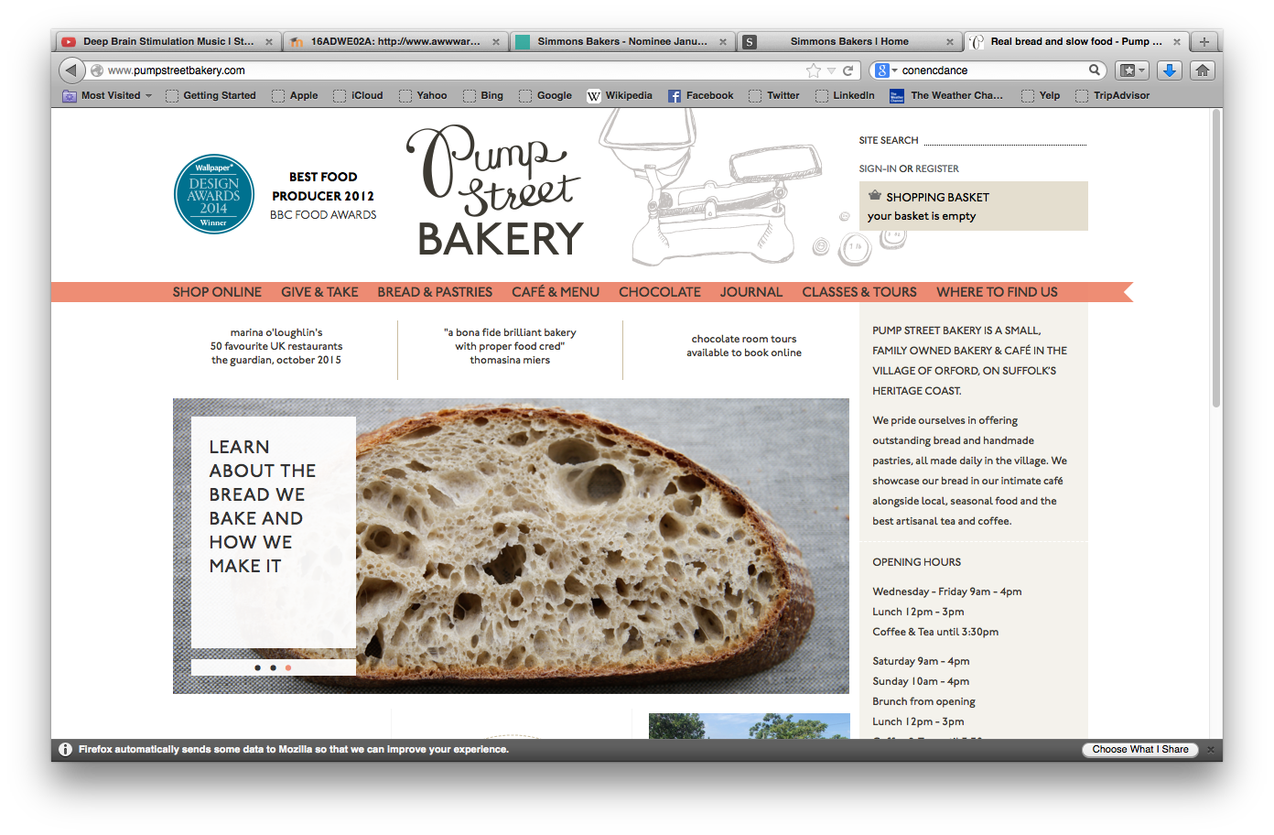

Website Research

Here are some examples of well-designed websites

<http://niedlovs.com/>

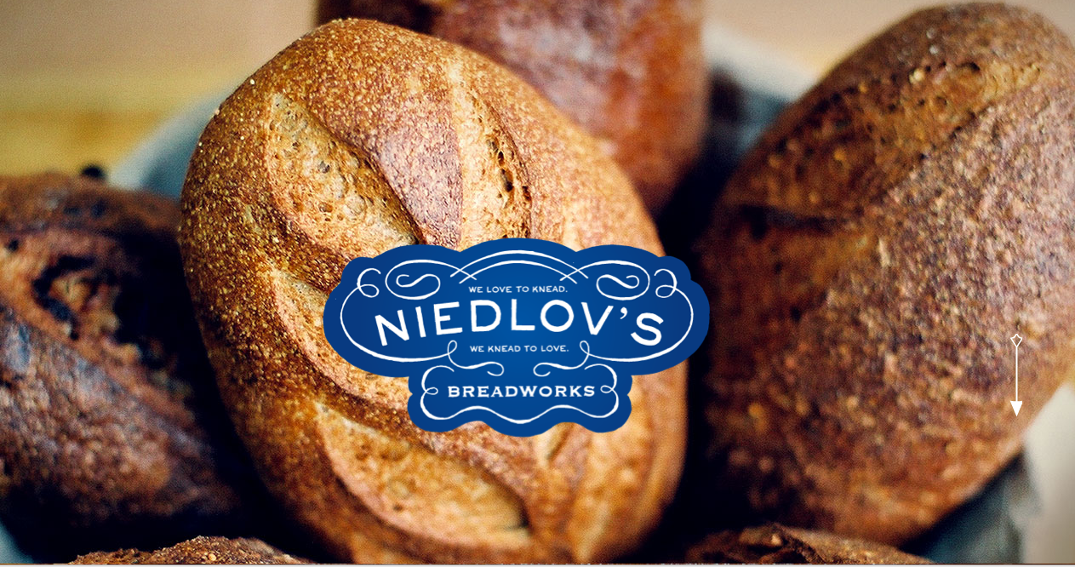

http://www.gnosh.co.uk/

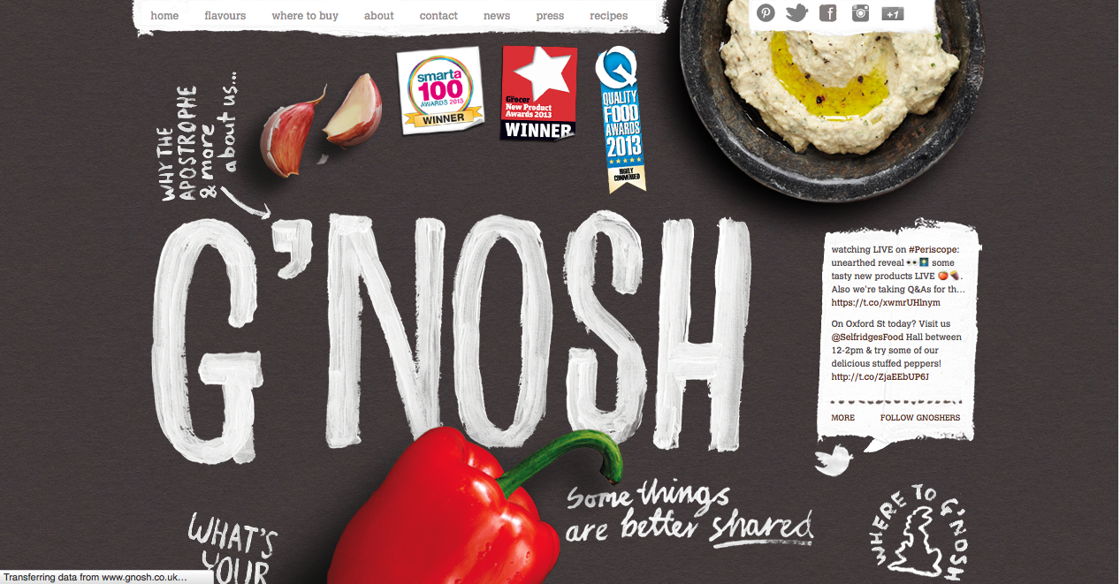

**Logo research**

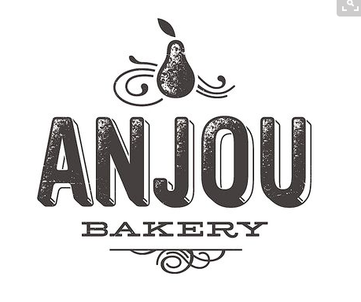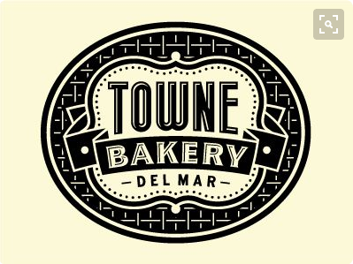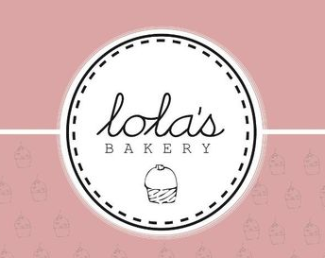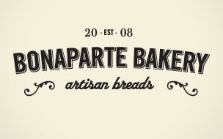

Logo Development



Final logo design {HERE}

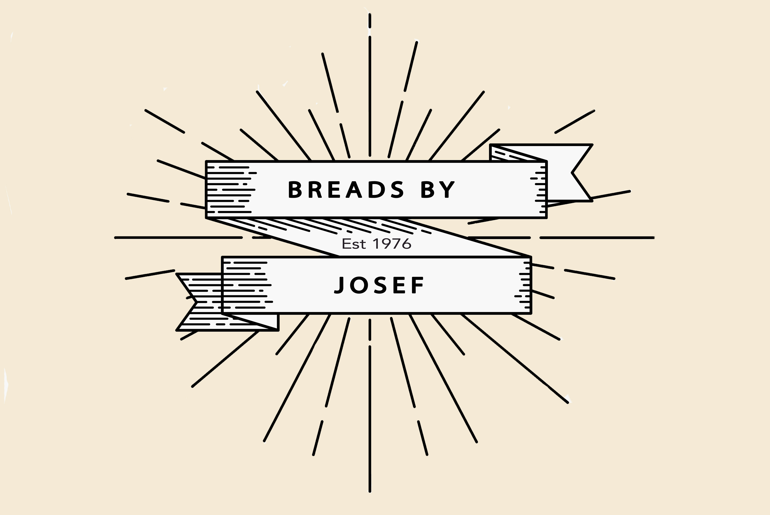

Sketches for website

Layout 1

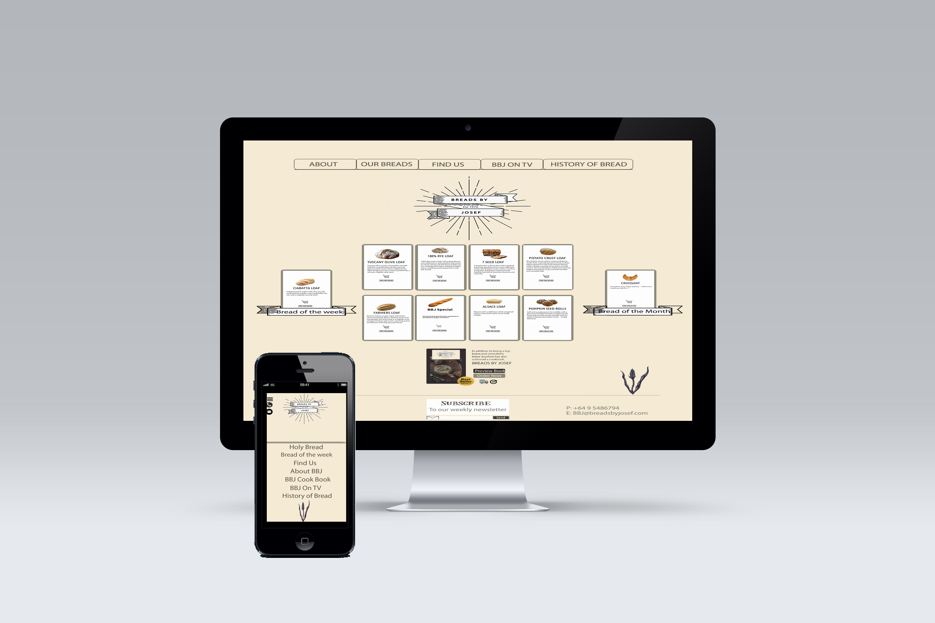

Colours & Fonts

Color swatch palette



**Fonts – Layout 1**

Sweet Pea

Myrid Pro Regular

Unbunty Bold

Unbunty regular

Les Mysteres de paris

**Fonts – Layout 1**

Les Mysteres de paris

Sweet Pea

Myrid Pro Regular

**Fonts – Logo**

*Avenir*

*AvenirLStd Light*

Website Mock-ups

Layout 1 Key features

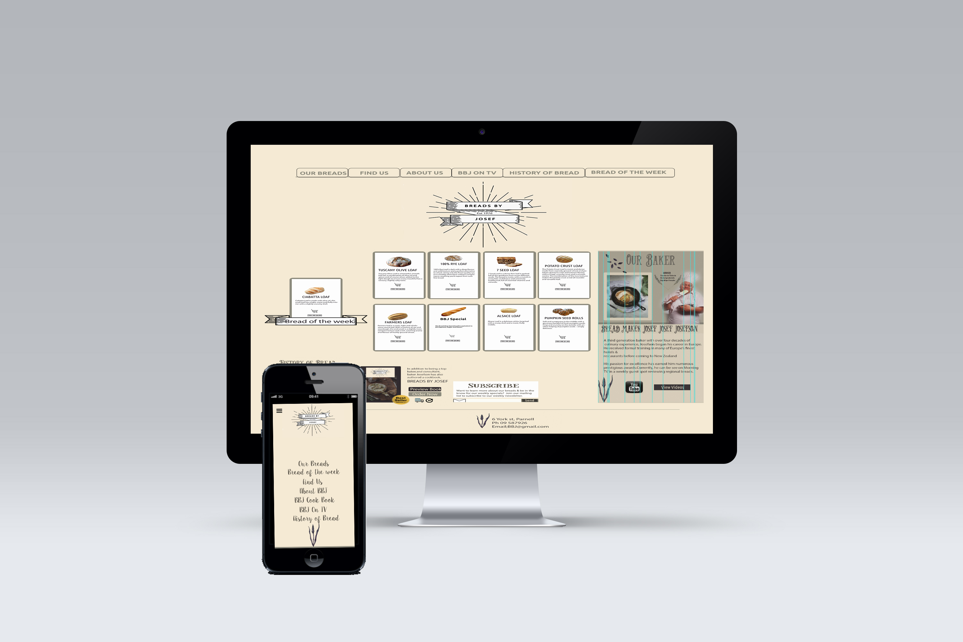

Layout 2



Timeframe

**Design & Build Phases**

Below are the phases we will follow to ensure a positive flow through the creation of your website project. This will actively involve you & improve the productivity of the project. There are four phases to the design process.

* Discovery Phase-Market research & sound planning
* Creative Phase- Design & approval f visual elements
* Technical phase- The site is built & developed in accordance to design.
* Review phase – Usability review & testing.

Usability Review

**Layout 1**

User 1: *I like the general look however there are to many fonts used, The backgrounds are uneven & it is to busy in some places.*

User 2: *Nice work! i like your fonts. maybe find a better picture of a map that isnt pixelated but other then that it looks good!*

User 3: *I like your colour scheme and the logo looks very professional. I like the font you have chosen for the headings. Perhaps the font on the top menu is a little hard to read?*

User 4: *The illustration is shaping up the theme. I already love how this look so far. Can't wait to see your finished work*

**Layout 2**

**User 1:** *I like the simple minimalistic design of your desktop lay out. Very clear & easy to navigate.*

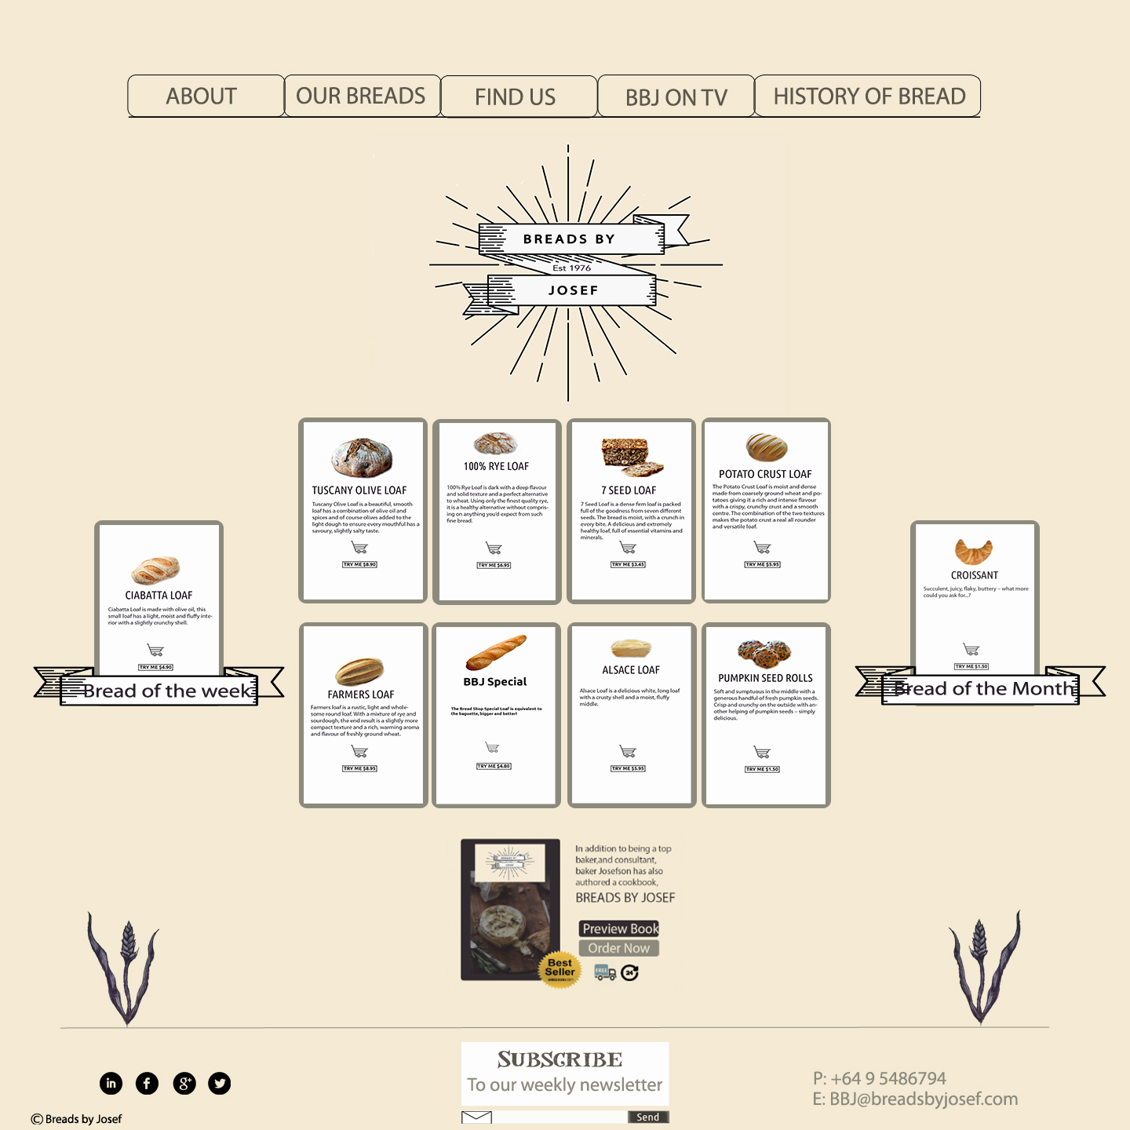

**Logo research links Source**

<http://www.pumpstreetbakery.com/>

<http://www.simmonsbakers.com/>

<http://www.scratchbakers.co.nz/>

<https://www.pinterest.com/pin/340514421798472426/>

<https://www.pinterest.com/pin/340514421798472412/>

<https://www.pinterest.com/pin/340514421798472342/>

<https://www.pinterest.com/pin/340514421801175207/>

General research

<http://www.verynicesites.com/page/50>

Images

http://www.thegirlwholovestost.com

http://www.thegraficsfairy.com

http://www.finedining.com

<http://www.finedininglovers.com>

Resource links

Mac & Iphone mock up images

<http://www.pixeden.com/psd-mock-up-templates/cinema-display-psd-mockup>

Shopping cart

https://www.iconfinder.com/search/?q=shopping%20cart <https://www.iconfinder.com/search/?q=shopping%20cart>

Bread of the week

<http://www.kentonlibrary.org/events>

Email icon

<http://velocitymacinstall.com/wmac/v54-1211775840?dp=5005&sub_id=00014941p032855004902&lr=1>

Phone icon

<http://velocitymacinstall.com/wmac/v54-1211775840?dp=5005&sub_id=00014941p032855004902&lr=1>

Bread in pan image http://youngaustinian.com/recipes/

**Cost Estimate**

Website design & building for Bread by Josef

Date : 03 March 2016

|  |  |
| --- | --- |
| Service Provided By Du Bont Creative Ltd | Cost NZD |
| Logo Research & Development | $500.00 |
| Website design & mock up. Mobile & Desktop views | $1,300.00 |
| Photoshop manipulation of existing content | $600.00 |
| Website build Front & backend development | $2,500.00 |
| Documentation & Maintenance work | $500 |

Total $5,3000

G.S.T $795.00

Total inc GST $6,095.00

**PLEASE NOTE**

Quotations are valid for 30days from the date stipulated on the estimate. Extra service fee may be charged if the projects require different or further services. A deposit, 50% of total amount, is required before beginning projects.

**Contract**

Website design for Breads By Josef

Identification of the Parties

This agreement is made between Concepts By Josefson Ltd, trading as Breads By Josef, and the Du Bont Creative Ltd.

**Contract**

A contract will be signed before the commencement of the project based on the agreement between the client and the developer. Signing the contract reflects the understanding of obligation and responsibility to the project by both the client and the developer.

**Terms**

* The content of this proposal is confidential and shall only be used for this particular project by both the client and the developer.
* Any changes to the content of the website should be indicated by the client before signing the agreement below. Otherwise additional charges may apply.
* This proposal is specifically prepared for Concepts By Josefson Ltd. Du Bont Creative owns the copyright of the design in this proposal until full payment has been made for the project.  Agreement  If the proposal meets your requirements and you wish for the developer to commence the project, please sign below.



Agency

Du Bont Creative Ltd

Name : Bianca Sanders

Position : Designer/ Developer

Date : Signature :

Client

Conepts By Josefson Ltd.

Name : Position :

Date : Signature :